

**Software Requirements**

**Specification**

**for**

**Purchase and Store-Procedures**

**Prepared by:**

SHUBHAM RAJANI(2018239)

DEEPAK SINGH(2018325)

SUYASH KHARE(2018257)

PAMPATI VARSHITH KUMAR(2018346)

SAURABH SINGH BALKE (20BCS201)

SAHIL SAINI(20BCS189)

**Last update:**

15th April 2023

# Table of Contents

**Revision History i**

1. **Introduction 3**
   1. Purpose 3
   2. Module Scope 3
   3. References 3
2. **Overall Description 3**
   1. Module Perspective 3
   2. Module Functions 4
   3. User Classes and Characteristics 5
   4. Assumptions and Dependencies 5
   5. Entity Relationship Diagram 6
3. **External Interface Requirements** 
   1. User Interfaces 6

3.3 Software Interfaces 6

1. **System Features (Functional Requirements) 7**
   1. Indent filing 7
   2. Indent Approval 8
   3. Stock Entry 10
2. **Current progress in web module 12**
3. **Current progress in App module 13**

**Revision History**

| **Name** | **Date** | **Reason For Changes** | **Version** |
| --- | --- | --- | --- |
| PS_1.0 | 01/02/2021 | Initial SRS | V1.0 |
| PS_1.0 | 23/01/2023 | Proposed some new endpoint for handling errors | V1.0 |

# Introduction

## Purpose

There exists a lot of time overhead and paper-work involved in the process from indent filing of stock to its final issuance to the indenter .The whole process is quite cumbersome and also inconvenient for different actors involved in this process. With the use of Purchase and Store, the whole notion of indent filing would undergo a major shift from the paper-work based approval of stocks to online.

The project aims at designing and implementing a user-friendly approval of filed indent, which addresses the above-mentioned shortcomings of the traditional system. It would also cater to the needs of different classes of users, i.e., Employee(s), Head(s), Director, Registrar, Purchase Officer, and Dealing assistant.

## Module Scope

The Scope of the Purchase and Store Procedures includes:

⮚ Providing a means for filing an indent.

⮚ Providing a means for tracking the status of the filled indent.

⮚ Providing secured means to get the indent approved.

⮚ Providing a means to keep track of stocks procured/present.

## References

1. [Indent Form](https://www.iiitdmj.ac.in/downloads/forms/Indent%20Form.pdf)
2. SRS of File Tracking System /* Link to be added */
3. SRS of Estate Management (PS-2)/* Link to be added */

# Overall Description

## Module Perspective

Indenter (faculty/staff) has a web-based user-interface through which they can interact with the Purchase and Store Procedures and perform indent filing. There is a login page for the users (faculty/staff) from where they can log into their accounts. After successfully logging into the account, the user can file an indent for the required product by filling up the indent form and forwarding it to his head/boss. Indentors can also view the status of its approval by higher authorities. This form is part of the employee-side interface.

Higher authorities (Head/Director) also have a web-based user-interface through which they can interact with this module and can view the received application of indent filed by the indenter. He/She can also give a remark for its approval/rejection. These form the part of the head/director interface.

Purchasing officer also has a web-based user-interface through which he/she can view the approved application and can check the current availability of funds with the corresponding department to give it financial approval.

Dealing assistant has a web-based user interface through which he/she can maintain the entry of procured stocks in the database.

Finally, the bill payment will be processed by the account section.

## Module Functions

This module can be used to file an indent by faculty/staff member, get the indent approved by authorities, manage stocks, and also ensure a transparent system to keep track of the application status and payments involved.

An indenter is allowed to fill indent form(s), which will be sent for approval to the concerned person(Director/Registrar) and after approval the procurement procedure will be initiated, and when the items(s) are delivered, an entry of procured items will be made in stock tables followed by payment for the items received.

## User Classes and Characteristics

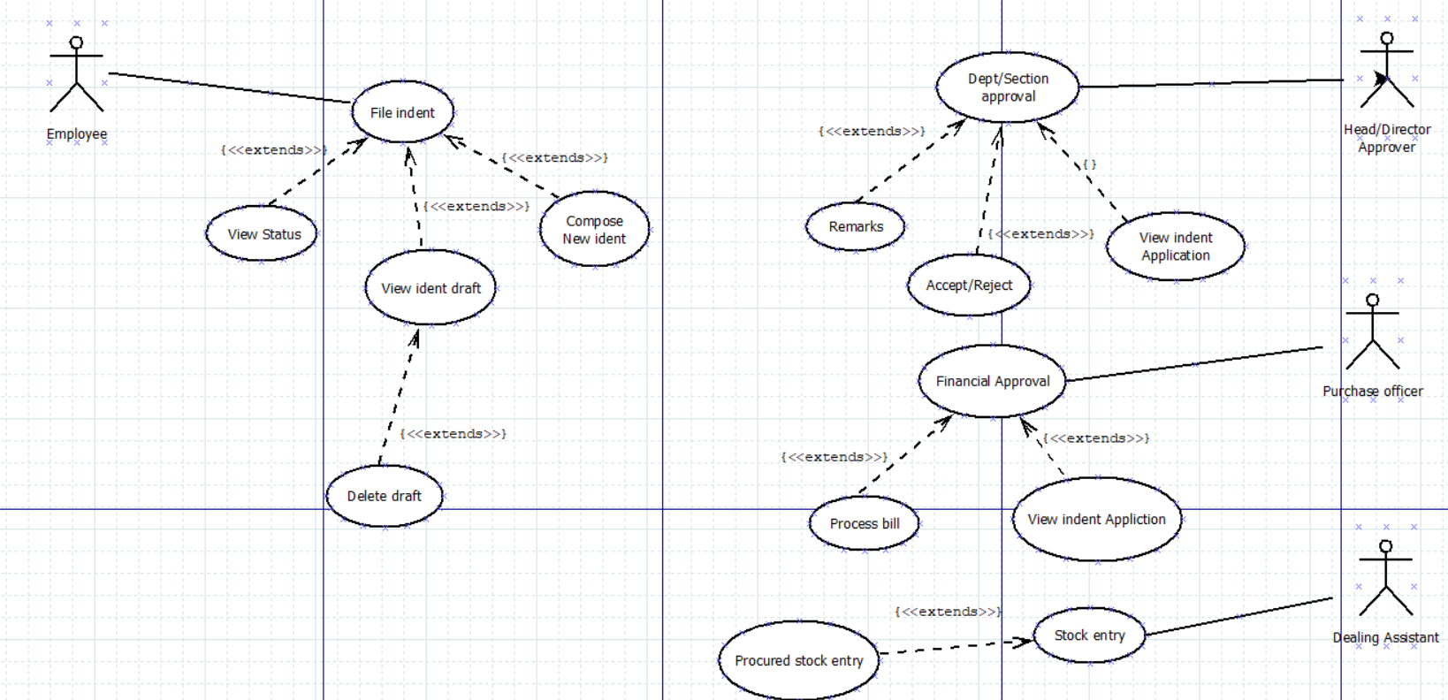

Following are the users of the module

**Indenter:** An indenter is a person serving the PDPM-IIITDM Jabalpur in some capacity, like a faculty or a staff and should have a PF number and an official institute email id, which should be used for accessing the system.

**Approver:** An approver is a person who will approve the indent filed by the indenter, depending on the indenter,the approver can be Director(in case of faculty) and Registrar(in case of staff) ,in some cases the file needs to be approved by an intermediate authority(like HOD) before it is sent to the upper authority.

**Purchasing Officer:** The person responsible for procurement of the items which have been approved by authorities.

**Dealing Assistant:** The person responsible for stock entry of products received. He/she can maintain the entry of procured stocks in the database after the bills are submitted.

## Assumptions and Dependencies

1. Once the indent is approved by the authority, it is assumed that available funds are sufficient enough to procure the item(s) i.e., no fund checking is performed after indent approval.

2. It is assumed that sufficient storage capacity is present for the storage of item(s) once they are added to the stock table.

3. Procurement of the products is done offline and need not be implemented in any module.

## Entity Relationship Diagram

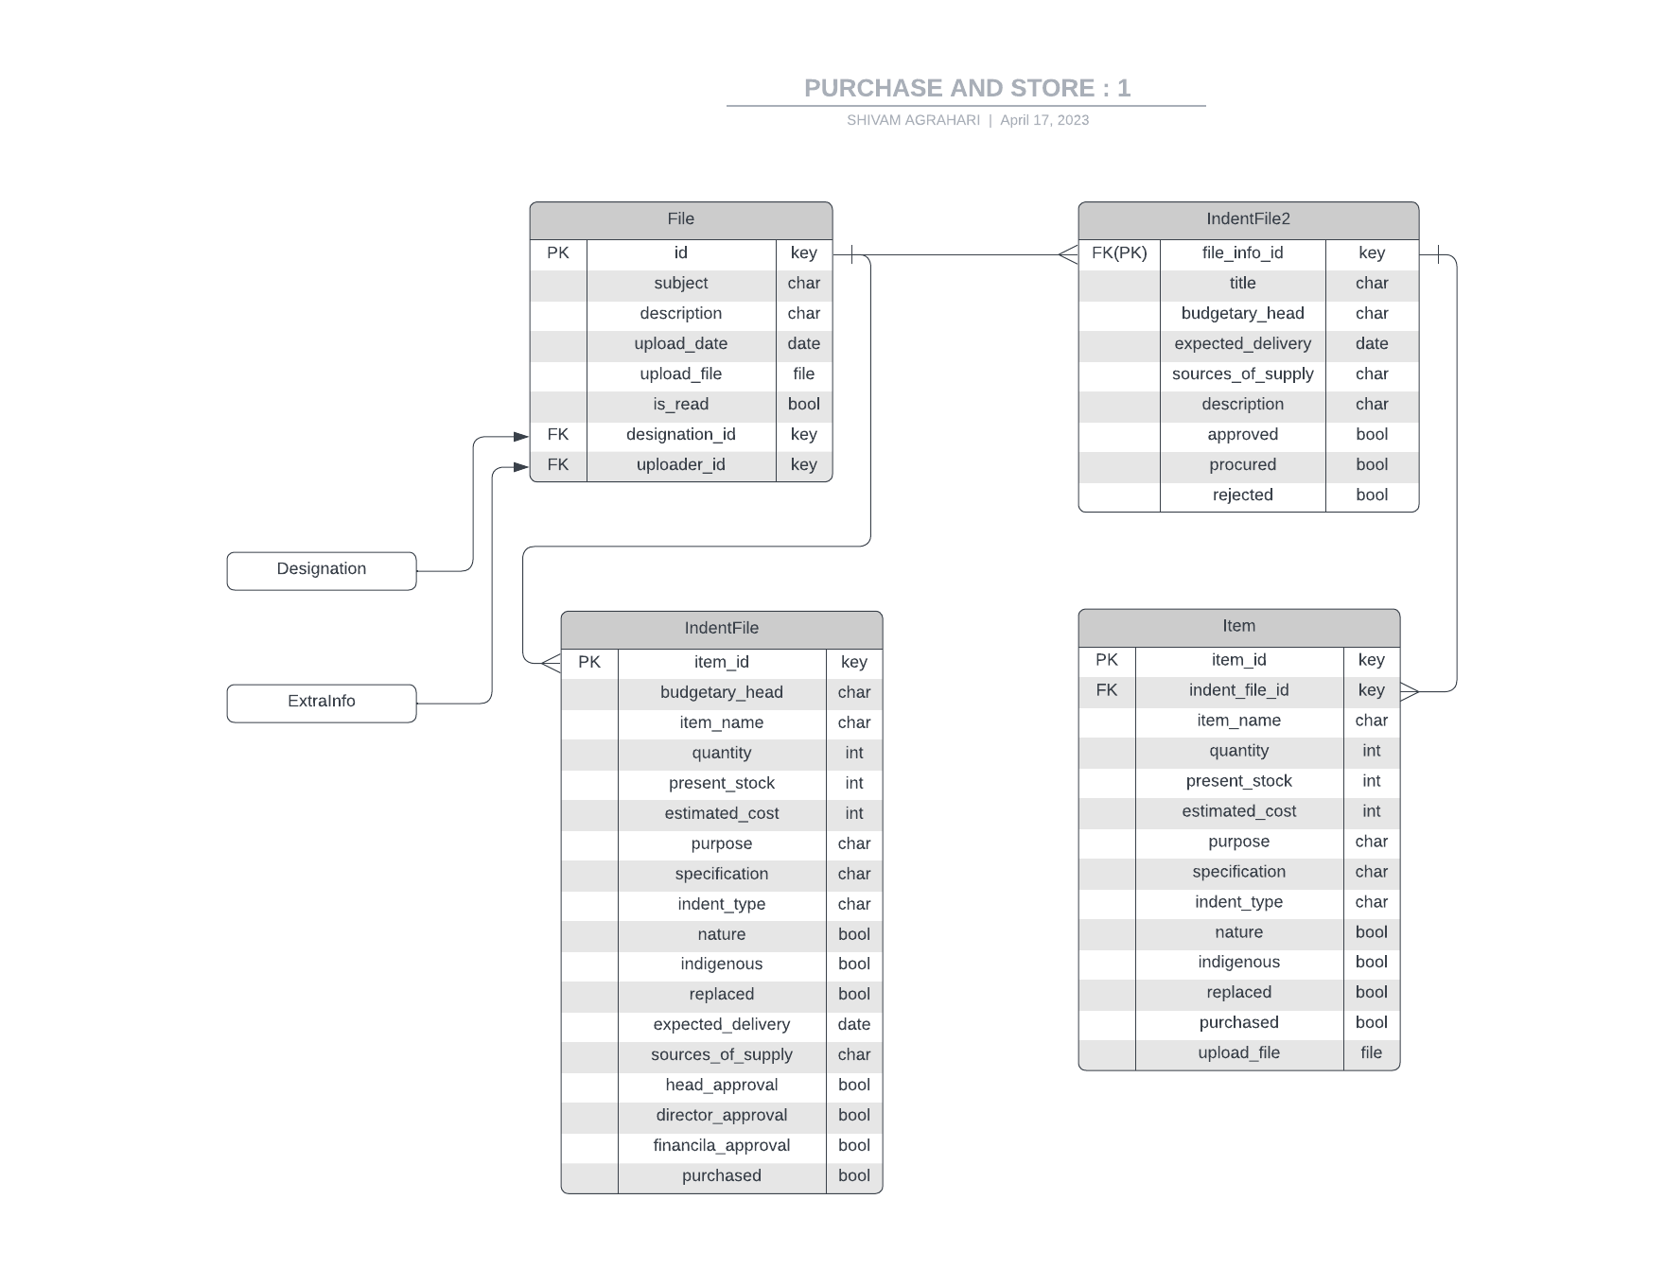

# External Interface Requirements

## User Interfaces

**Indenter ->** In this module on main interface, there will be two main buttons to create a new indent and view draft indents. This interface will display all the designations hold by the user by which he can get the drafts according to their designation/position. He can delete/ send the indent using respective buttons in the draft section. There will be an option to view status of filed indent. This interface is going to have a connection with section approval interface. There is a notification list so that he can be able to see any messages from approver.

**Approver ->** The dashboard of Approver will contain all the proposed indents, he can accept /reject the indent using respective buttons, if rejected, he has the option to send a message to indenter(why he rejected it) also, he has the option to accept the indent application and send it to Purchase Officer for further processing. There will be a notification panel for approver so that he can always get to know about the new indent applications. This interface has a connection with 2 other interfaces(Indenter, Purchase Officer).

**Purchasing officer ->** The main interface will have a list of all the indents approved for procurement and the actor will also be provided with the option to process the bill for funding and transfer the billing procedure to dealing assistant.He/She checks the indents received from approver and checks the available funds from a particular department.If the funds are insufficient actor can add remarks and send the application back to indenter, else actor sends the application to dealing assistant for further processing. This interface has a connection with 3 other interfaces(Dealing Assistant , Approver , Indeter).

**Dealing Assistant ->** The main interface will have the option of stock entry that will be performed after procurement of required stocks and all the available stocks will also be displayed in the dashboard, the available stocks can also be viewed in the Estate Management module.

All actors have a logout/login button, and the different interfaces are available to actors solely on the basis of login information. That we call as secured login

## Software Interfaces

The indent filing system will build upon the File Tracking System with an additional approved filed which determines the acceptance/rejection status as well as for viewing the status of an application of the filed indent also the stock entry system is associated with the Estate Management System module to provide complete functionality to the module.

Indenter interface will have the option to compose a new indent which will be forwarded to the head of dept./section via File tracking system. The head will be notified with the help of notification.

The Head (Approver) interface in turn will give the remark for application and indenter will be notified in the dashboard which can be viewed in “view status” section.

As soon as the Head approves the application, it will be forwarded to the director/registrar through a File tracking system and the indenter will be notified for all approvals.

This module will also interact with Estate Management (PS-2) for entry of stocks details by the Dealing assistant. The details will be entered in tabular form.

# System Features (Functional Requirements)

Here we require a file tracking system for all the interfaces for file forwarding. We also need a notification list to check the latest application we received. We need to allow only authorized persons to login(secured login) through the particular module . We also need an accept or reject option only to the head/director .The particular designated person should only do the procurement stock entry(dealing assistant) others can not access the database.

## Indent Filing

⮚ **Use Case #1: Indent Filing**

| **UC ID** | UC#1 | |
| --- | --- | --- |
| **Use case**  **Name** | **indent_filing** | |
| **Description** | This use case specifies filing of an indent by the indenter, after the form is filled it is forwarded to higher authorities for approval. | |
| **Actor** | Indenter | |
| **Precondition** | The indenter must be logged-into the system. | |
| **Main Flow** | **S NO**. **Description** | |
| **Main Flow** | 1 | A Purchase and Store Dashboard is displayed initially to indenter after successful login. |
| 2 | The system presents the option of filing a new indent or tracking the status of past indents filed. |
| 3 | An employee selects one of listed options to perform file operations |
| 4 | Following operations can be performed by an employee:  **File an Indent**: A new indent can be created by filling the indent form by providing all the necessary details.  **View Indent Status**: Status of a previously filed indent can be viewed by an indenter on the available dashboard. |

|  | 5 | A successful message is displayed when indent is filed. |
| --- | --- | --- |
| **Post**  **Condition** | After operations are successfully performed, they will be reflected in the database. | |
| **Alternate**  **Flow** | **ID. Description** | |
| **Alternate**  **Flow** | A1 | All fields are compulsory to be filled. If any field is left empty, an error pops up. |
| A2 | If the 'cancel' option is selected, then the operation will be aborted, and the system will be redirected to the home page. |
|  | **Post-condition –** The system displays the initial screen. |
| **Global**  **Alternate**  **Flow** | G  A1 | An employee can ‘cancel’ the operation at any time by exercising such an option. |
|  |  | **Post-condition –** The system returns to the actor’s Dashboard – initial screen. |

**4.2 Indent Approval**

⮚ **Use Case #1: Section Approval**

| **UC ID** | UC#2 | |
| --- | --- | --- |
| **Use case**  **Name** | **Department/Section Approval** | |
| **Description** | This use case specifies the procedure for acceptance/rejection of proposed intent by department/section. | |
| **Actor** | Head/Director/Registrar | |
| **Precondition** | The user must be logged into the system | |
| **Main Flow** | **S NO**. **Description** | |
| **Main Flow** | 1 . | User finds all proposed indents in his Inbox. |
| 2 | When the user clicks on an indent, he has the option to accept/reject the given indent.  Actor can also give remarks if any changes are needed. |
| 3 | The indenter will be notified about the status(acceptance/rejection) along with the  remark. |
| 4 | If the application is accepted the Purchasing Officer is notified to proceed with procurement of item(s), if rejected the indenter has the option to edit the indent or file a new one . |
| **Post**  **conditions** | After the indent is approved the procurement procedure is initiated. | |
| **Alternate**  **Flow** | **AF ID. Description** | |
| **Global**  **Alternate**  **Flow** | GA1 |  |
|  |  | **Post-condition –** The system returns to the employee ‘Dashboard’ – initial screen. |

⮚ **Use Case #2: Financial Approval**

| **UC ID** | UC#3 | |
| --- | --- | --- |
| **Use case**  **Name** | **Financial Approval** | |
| **Description** | This use case describes the procedure for financial approval of indent | |
| **Actor** | Purchasing Officer | |
| **Precondition** | The Purchasing officer must be logged-in | |
| **Main Flow** | **S NO**. **Description** | |
| **Main Flow** | 1 | User finds all proposed indents which are approved by the director/registrar in his Inbox. |
| 2 | When the user clicks on an indent, he/she can check for the availability of funds with the corresponding department/section. If sufficient funds are available, then he can give financial approval for the proposed item, otherwise reject it. |
| 3 | The indenter will be notified about the status(approval/rejection) along with the  remark by purchasing officer. |
| 4 | If the application is accepted, the Dealing assistant is notified to proceed with procurement of item(s). |
| **Post**  **conditions** | After approval/rejection, the corresponding status is reflected in the database. | |
| **Alternate**  **Flow** | **AF ID. Description** | |
| **Sub Flow** | S1 | The indenter will be notified about the status(approval/rejection). |
|  | S2 | Dealing assistant is notified to proceed with the procurement of item(s) after getting financial approval. |
|  |  | **Post-condition –** The system returns to the user ‘Dashboard’ – initial screen. |

**4.3 Stock Entry**

⮚ **Use Case #1: Stock Entry**

| **UC ID** | UC#4 | |
| --- | --- | --- |
| **Use case**  **Name** | **Stock_Entry** | |
| **Description** | This use case describes the entry and status of item/stock by Dealing assistant | |
| **Actor** | Dealing Assistant | |
| **Precondition** | The actor must be logged-in | |
| **Main Flow** | **S NO**. **Description** | |
| **Main Flow** | 1 | This actor gets the approved funding details of indent from the Purchasing Officer in inbox |
| 2 | After procurement of stocks, entry is done in the database about the funding and details of the purchased item(s) |
| 3 | After stocks entry is done the actor sends the approved file to account section for funding |
| 4 | Also after the purchase the user enters the bills in the stocks database |
|  | 5 |  |
| **Post**  **conditions** | After the successful stock entry. The Account Department will process the bills. | |
| **Alternate**  **Flow** | **AF ID. Description** | |
| **Alternate**  **Flow** | A1 |  |
| **Global**  **Alternate**  **Flow** | GA1 | . |
|  |  | **Post-condition – After successful stock entry the system will provide us confirmation message** |

# 6. Current progress in the WEB-MODULE.

| **S. No** | **Progress Description** | **Category** | **Remarks** |
| --- | --- | --- | --- |
| 1. | Implemented delete indent functionality. | Backend | [PR](https://github.com/FusionIIIT/Fusion/pull/1012) has been merged |
| 2. | Designed a page for adding multiple items into a single indent. which includes a modal with all the necessary input fields. It will allow users to add all items in a single indent. | Frontend | [PR](https://github.com/FusionIIIT/Fusion/pull/1043) has been merged |
| 3. | Fixed errors regarding stocks_ login URL. Implemented API for redirecting to purchase and store home page | Frontend / Backend | [PR](https://github.com/FusionIIIT/Fusion/pull/1074) has been merged |
| 4 | Item and IndentFile2 table has been added in database to support multiple items in same indent | Database | [PR](https://github.com/FusionIIIT/Fusion/pull/1142) has been merged |
| 5 | Created endpoint as well and a new form for creating/filling indent with multiple items. | Frontend / Backend | [PR](https://github.com/FusionIIIT/Fusion/pull/1143) has been merged |
| 6 | Created 2 endpoints for getting the drafts/saved files of indent file for the user.  draft will provide all the designations hold by the user.by which we can get the drafts according to their designation/position. | Frontend/ backend | [PR](https://github.com/FusionIIIT/Fusion/pull/1174) has been merged |
| 7 | Implemented page to display filled indent list | frontend | [PR](https://github.com/FusionIIIT/Fusion/pull/1247) has been merged |
| 8 | Developed indent tracking and item-wise purchase status whole functionality. | Frontend/ Backend | [PR](https://github.com/FusionIIIT/Fusion/pull/1208) has been merged |

# 7. Current progress in the APP-MODULE

| **S. No** | **Progress Description** | **Category** | **Remarks** |
| --- | --- | --- | --- |
| 1. | A Material Design checkbox.  The checkbox itself does not maintain any state. Instead, when the state of the checkbox changes, the widget calls the onChange callback. | Frontend | [Code](https://github.com/Manish-ku-mar/fusion-test1) Regarding This |
| 2. | Designed a page for adding multiple items into a single indent. which includes a modal with all the necessary input fields. It will allow users to add all items in a single indent. | UI/UX | [Figma](https://www.figma.com/file/OQsbRlouPqwzYA15kt563x/P%26S?node-id=0%3A1) has been created  for this design |
| 3. | Implemented indent form with all the necessary input field | Frontend | [Code](https://github.com/Manish-ku-mar/fusion-test1) Regarding This |
| 4 | Code for the final design is completed and a new multiple items feature is also added. | Frontend | [Figma](https://www.figma.com/file/OQsbRlouPqwzYA15kt563x/P%26S?node-id=0%3A1) has been created  for this design |